**Project Design Phase-II**

**Technology Stack (Architecture & Stack)**

|  |  |
| --- | --- |
| Date | 03 October 2022 |
| Team ID | PNT2022TMID27756 |
| Project Name | Project – AI-Powered Nutrition Analyzer for Fitness Enthusiasts |
| Maximum Marks | 4 Marks |

**Technical Architecture**

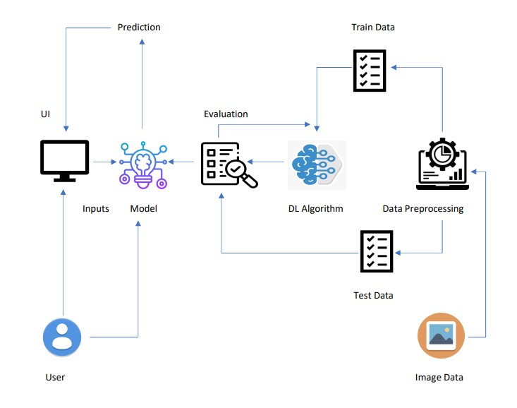

**Table-1 : Components & Technologies:**

|  |  |  |  |
| --- | --- | --- | --- |
| **S.No** | **Component** | **Description** | **Technology** |
| 1. | Application | User interacts with application for the prediction of Nutrition | Python, Java, HTML,SQL, Android studio ,JavaScript, ReactJS, tailwindCSS |
| 2. | Database | Data Type, Configurations and data will be stored | MySQL, JavaScript |
| 3. | Cloud Database | Database Service on Cloud | IBM DB2, IBM Cloudland, etc. |
| 4. | File Storage | File storage requirements | The storage will be based on Cloud |
| 5. | Machine Learning | Purpose of Machine Learning Model | ANN, CNN, RNN |
| 6. | Notification | Notification will be sent from the server | Send Grid |
| 7. | File Storage | File storage requirements | IBM Block Storage or Other Storage Service or Local Filesystem |
| 8. | External API | Purpose of External API used in the application | Aadhar API, Stripe |
| 9. | Machine Learning Model | Purpose of Machine Learning Model | OpenCV, MATLAB |
| 10. | Infrastructure (Server / Cloud) | Application Deployment on Local System / Cloud Local Server Configuration:  Cloud Server Configuration : | Local, Cloud Foundry, Kubernetes, etc. |

**Table-2: Application Characteristics:**

|  |  |  |  |
| --- | --- | --- | --- |
| **S.No** | **Characteristics** | **Description** | **Technology** |
| 1. | Open-Source Frameworks | open-source frameworks used | SendGrid, Python, jQuery |
| 2. | Security Implementations | Request authentication using encryption | Encryptions, SSL certs |
| 3. | Scalable Architecture | The scalability of architecture consists of 3 tiers | Web Server – HTML, CSS, JavaScript  Application Server – Python Flask  Database Server – IBM Cloud |
| 4. | Availability | Availability is increased by loads balancers in cloud  VPS | IBM Cloud hosting |
| 5. | Performance | The application is expected to handle up to 4000 predictions per second | IBM Load Balance |